A Citizen-centred Collaboration for Energy Efficiency
Submitted by Joël Bourgeoys & John Kenney
OEE Social Innovation Unit
Natural Resources Canada (NRCan)
This is the story of a cross-jurisdictional partnership between three levels of government to research, co-design and test prototypes with citizens to inform and improve the experience and uptake of home energy labeling and reporting in the context of the City of Edmonton’s Spot the Difference program. The core team was comprised of representatives from three levels of government (Natural Resources Canada’s (NRCan) Office of Energy Efficiency (OEE), the Province of Alberta’s CoLab, and the City of Edmonton) with support from Situ Strategy.
What was the ISSUE?
The Pan-Canadian Framework on Clean Growth and Climate Change commits partners to advance energy labeling and reporting in buildings to make energy use visible and inform energy efficient actions, like retrofits. Understanding the opportunities and barriers to label adoption can inform continuous improvement and innovation opportunities.
The Province of Alberta’s CoLab and NRCan’s OEE Social Innovation Unit leveraged federal, provincial and municipal networks to explore opportunities to work together to advance a priority that would benefit from collaboration and a citizen-centred approach. Approximately 6 percent of Edmonton homes had energy labels and the City was gearing up a residential labeling program using the EnerGuide labeling and reporting system, a federal tool implemented by municipalities, provinces, and territories across the country. We had our common priority and challenge: how might we improve the residential labeling and reporting experience and uptake to improve energy efficiency in homes in the City of Edmonton?
What ACTION was taken?
In 2016-17, we brought the team and other partners and stakeholders on board, including a service design consultant (Situ Strategy) and a home energy advisor, to deliver a project that used citizen-centred design methods and approaches.
We focused on:
- Energy efficiency behaviours and motivations of homeowners;
- EnerGuide tools and service: home energy evaluation, labeling, and renovation (aka retrofit) process; and
- Behavioural aspects of message framing.
User Research
The City had a brilliant way to engage citizens in the initial design of their Spot the Difference program - they held a contest to win a free home energy evaluation. Twenty-four homeowners won a free home evaluation and agreed to be part of the service co-design. Team designers (from Situ Strategy and CoLab) engaged with homeowners during their home energy evaluation. They observed the evaluation process, interviewed homeowners about their energy use, past activities with energy efficiency and home upgrades, and presented the EnerGuide label and noted their understanding of it, as well as the EnerGuide process.
Sense-making
The team came together over an initial two days in Edmonton for the project’s sense-making phase, which included reviewing, extracting and clustering interview data to look for patterns, insights, and opportunities.
After receiving their home evaluation report, homeowners shared their experiences and before and after attitudes, and co-designed improvement opportunities based on the challenges they identified.

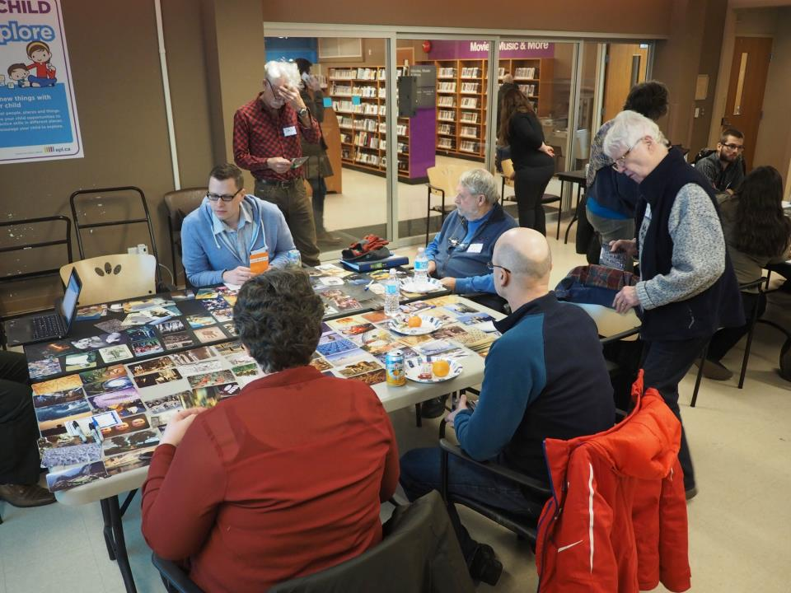
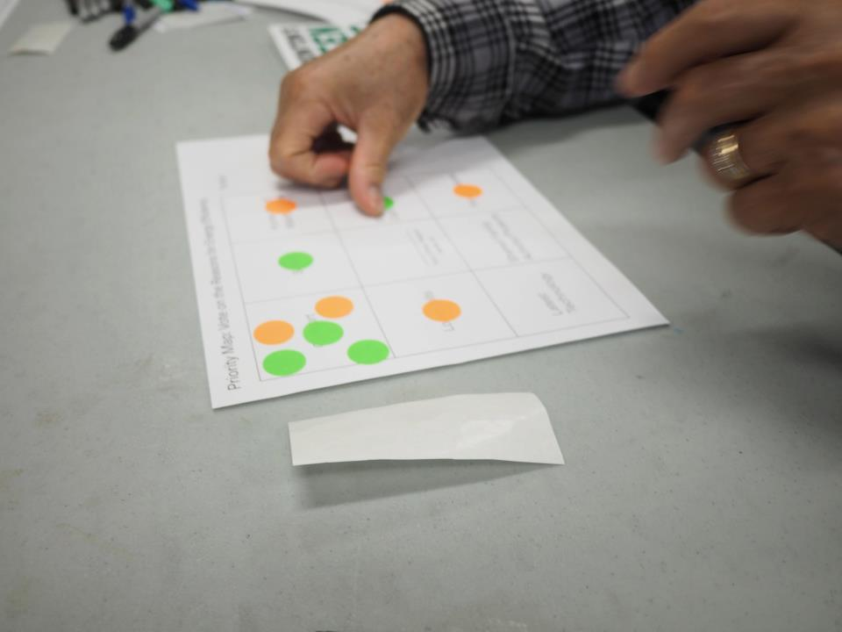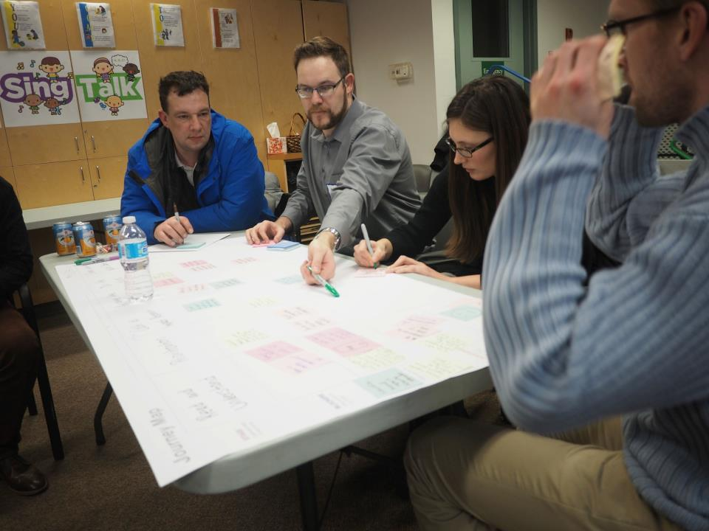

Prototyping & Testing
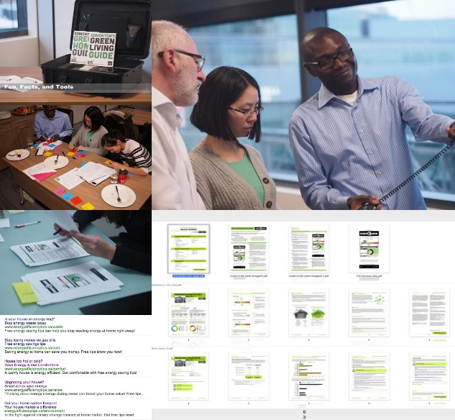
Following some post-workshop analysis completed by the team from our various locations, select members reconvened for three days to brainstorm ideas based on the insights from the initial research and co-design workshops with homeowners. Dozens of ideas were short-listed according to their potential impact and feasibility.
We created three low-fidelity prototypes to test, which enabled the low-cost rapid exploration of ideas for improving and supporting residential energy labeling related to:
- Messaging - Alternative Messaging and Framing through Google Ads.
- Energy Efficiency Block Party - Work with neighbourhoods or community leagues to raise energy literacy and awareness.
- The EnerGuide Report - Create a redesigned EnerGuide report to address issues identified in our codesign workshops.

What was the IMPACT?
Our project operated on a separate, but interrelated, track alongside the City’s overall Spot the Difference program planning to inform its design and rollout.
It also provided NRCan and partners with an example of how collaboration and upfront user research can inform opportunities to design, test and scale improvements directly with citizens and stakeholders.

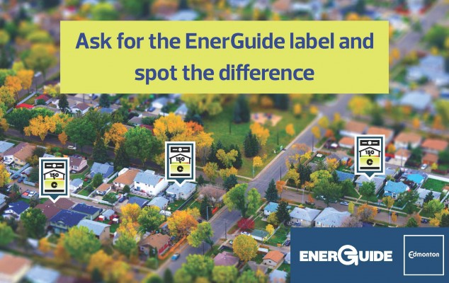
In 2017-18, the City was successful in acquiring NRCan funding through a Call for Proposals process, which is supporting continued experimentation and the delivery of its Spot the Difference residential labeling program over two years. Learning and results will be monitored and shared across jurisdictions.
Federally, OEE implemented evidence-based improvements to the EnerGuide home evaluation report to make it more readable and action-oriented for homeowners.
NRCan’s OEE is applying a similar policy and service innovation model in other contexts too, learning from our experience with this Federal-Provincial-Municipal partnership. OEE’s Social Innovation Unit is working with internal and external partners to identify other areas where cross-jurisdictional and multi-sectoral teams can work on micro-pilots or trials to accelerate shared learning and experimentation to inform promising proposals that scale energy efficiency actions and outcomes.

Principles for Success
The following principles for learning and success were put into practice by the core team comprised of representatives from NRCan’s Office of Energy Efficiency (OEE), the Province of Alberta’s CoLab, and the City of Edmonton:
Collaboration across Jurisdictions:
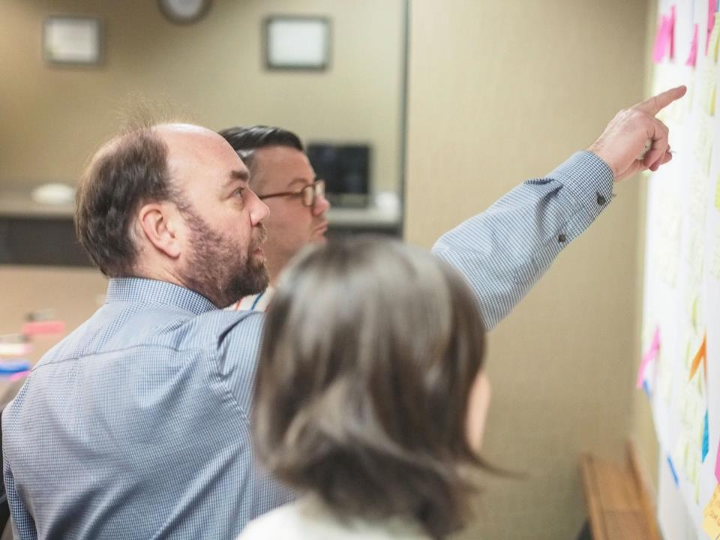
- Connecting municipal program delivery with federal and provincial policy helped to understand labeling and reporting across the policy-service continuum.

Collaboration Onsite:
- Collaborating onsite for two Edmonton workshops demonstrated commitment from all partners and advanced learning and action.
Direct citizen engagement & co-design:
- Behavioural field research
- Codesign workshops with citizens and the team
- Prototyping and testing
Clear Roles & Responsibilities
- A shared understanding of who was responsible for what and how we would work together was critical in a cross-jurisdictional partnership.
Being Adaptable to Evolving Contexts
- At one point during our project, the capacity of one of the partners was stretched so the team adapted to the shifting realities to keep the project moving. At another point, we had technical difficulties with the Messaging prototypes so shifted to ‘analog’ means of engagement and testing.

