EW Resources

Title: Statistical Power Calculator

Type of resource: Tool

Context for piece: One of the experts supporting an EW project thought this would be an excellent tool to have as part of a standard toolkit for experimentation.

Short explanation: Experiments can sometimes miss real effects simply because they do not collect enough data. If an effect exists, we want to be confident that our experiment can reliably detect such a ‘signal’ from the background noise. This is what we mean by statistical power and it is critical that any experimenter consider this issue before launching a study. This tool will help you estimate how big your study sample needs to be to detect a given effect size as statistically significant. Alternatively, if your sample size is fixed, this tool will tell you the minimum effect size you'll be able to detect as statistically significant. For more information, see this link

Credits / acknowledgements: Shared by Michael Kalin, NRCan Expert supporting EW (piece itself was designed by the UK Behavioural Insights Team)

Added as EW Resource: May 2018. Tool designed circa 2014

Key points: Click here to access the tool (online, free). See screenshot below
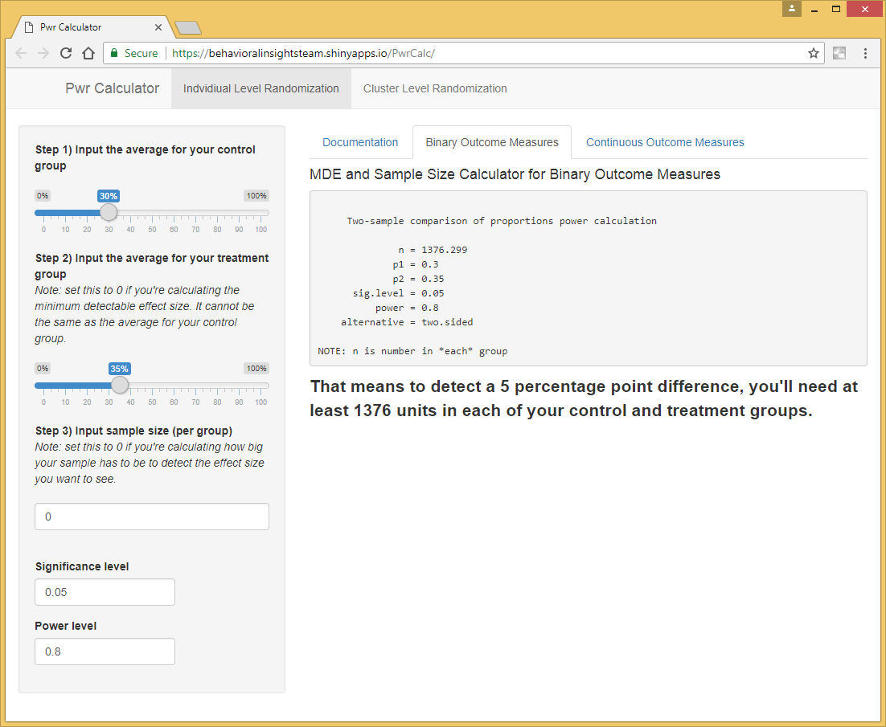
What is Experimentation Works? See Trello board, Medium blog and Gcpedia page (internal)

