Shaping our future employment services
With jobactive contracts due to cease in mid-2020, we were presented with an opportunity to explore new ways of working to help shape a future employment services that would better meet the needs of job seekers and employers. To achieve this goal, a specialised branch was established to lead work involving multi–disciplinary and sprint teams, technology, crowdsourcing and leveraging lessons learned from other policy processes.
Employment services—including jobactive, Disability Employment Services and the Community Development Program—provide a range of complementary programs to support specific groups and objectives. The largest program delivering employment services is jobactive. Achieving over 1.3 million job placements since its inception on 1 July 2015 and engaging with more than 650,000 people at any point in time, jobactive providers operate in over 1700 sites across 51 employment regions in metropolitan and regional Australia.
The original end date for the current employment services contracts was set for June 2020. This presented an opportunity for the department to consider a range of other factors that impact delivery of effective services including the changing labour market, advancements in technology and new thinking on how to support disadvantaged job seekers to find work.
‘Being part of a team to help develop the next employment services model is a great opportunity to enhance our policy design and service delivery. This includes trialling a range of methodologies and new technologies’ said Senior Policy Officer Patrick Fester.
This work got underway quickly by drawing on the expertise of areas across the department, other government agencies and external organisations to establish what was originally known as the Active Labour Market Assistance (ALMA) Branch, (subsequently renamed 2020 Project Office). Team members brought a range of skills including policy design, communication, user centred design and program implementation.
Using a variety of strategies, the team looked at new ways of designing and implementing services that could better meet the needs of job seekers and employers. A key part of this work was undertaking a human centred design approach including:
- Human Centred Design—the department, in collaboration with external organisation ThinkPlace, undertook a 12 month project exploring the motivations of job seekers, employment service provider perceptions, engagement with job seekers, the use of technology and interactions within the labour market. Take a look at the full report and key findings on the intranet.  - Idea generation—exploring what advice could be given to a job–ready job seeker as a challenge in the Department’s ideas management system, Spark. A range of ideas were suggested from leveraging current programs to cohabiting with retirement villages and creating an app. An idea using social media channels such as LinkedIn to help job seekers market themselves and connect with employers was selected to progress to the next stage of the process.  - Crowdsourcing—an external crowdsourcing platform MindHive sought ideas on how the department could design digital services to meet the needs of stakeholders with complex needs. MindHive members range from academics and researchers to members of the public. Ideas supported the notion of digital transformation while also recognising some job seekers needed face–to–face support. | 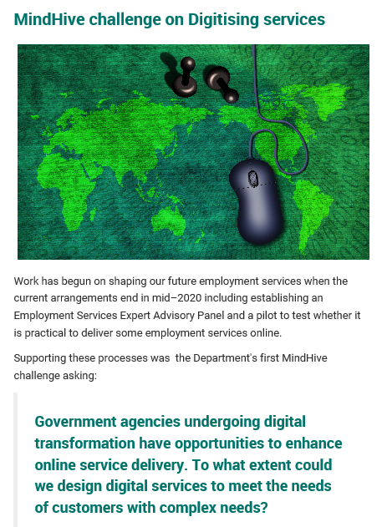

Another key part of this process was the establishment of an Expert Advisory Panel in January 2018. Panel members represented the needs of a range of key stakeholders including employers, providers and welfare groups. The Panel members brought with them a wide range of expertise and different perspectives critical to informing the design of a new model.
In consultation with the Panel, the Branch produced a public Discussion Paper to enable a broader range of stakeholders to engage in the discussions. While this method of engagement could be considered traditional, the paper’s content was developed using new methodologies for example inclusion of personas and journey maps to outline different policy scenarios. Personas were created based on user research gained by talking directly to job seekers, providers and other key stakeholders. Staff from across the Branch and wider department helped host the series of roundtables and forums around Australia. All of these strategies now represent the largest consultation process ever undertaken by the department.
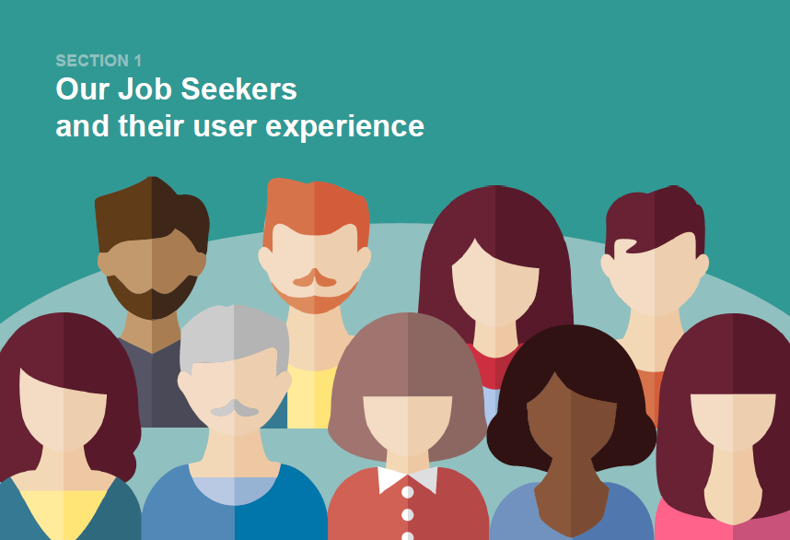 | 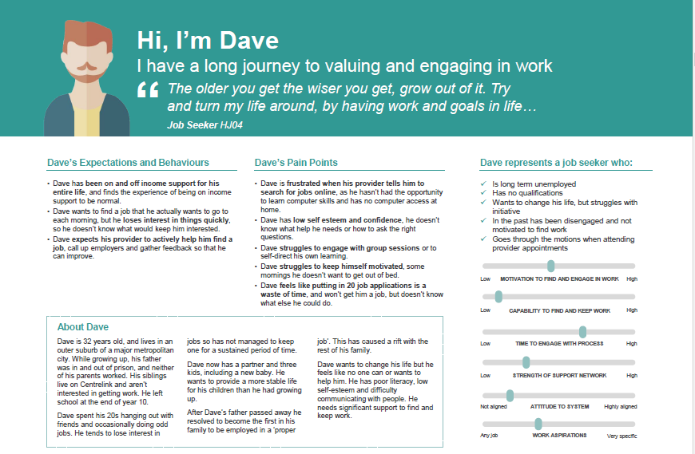
‘Consultation activities ranged from interviews, user research, public consultations, discussion papers, forums, crowdsourcing to external platforms. We adopted some innovative approaches to our policy design and consultation, by applying user centred approaches, we’ve ensured we can provide services which best meet the needs of the individual jobseeker’ said
User Experience Assistant Director Ian Sheldon.
Learning from others has been a fundamental aspect of the design of the future employment services model. The department’s Applied and Behavioural Economics team also trialled job seeker access to an online platform and material through a randomised control trial, and shared the findings with the 2020 Project Office team.
The Branch has also used learnings from the current online employment services trial, which began on 2 July 2018. This trial aligns with the Government’s digital transformation agenda and capturing user feedback to help inform the design of online employment services system to better meet the needs of job seekers in the future.
Following the announcement of the new model and Trial, the Project Office will continue the human centred design journey through user testing and stakeholder engagement to ensure successful implementation of the new model.
Read more about this consultation process and the new employment services model on the Department’s website: https://www.jobs.gov.au/new-employment-services-model

