Dutch Reach Project Strategy Flow Chart
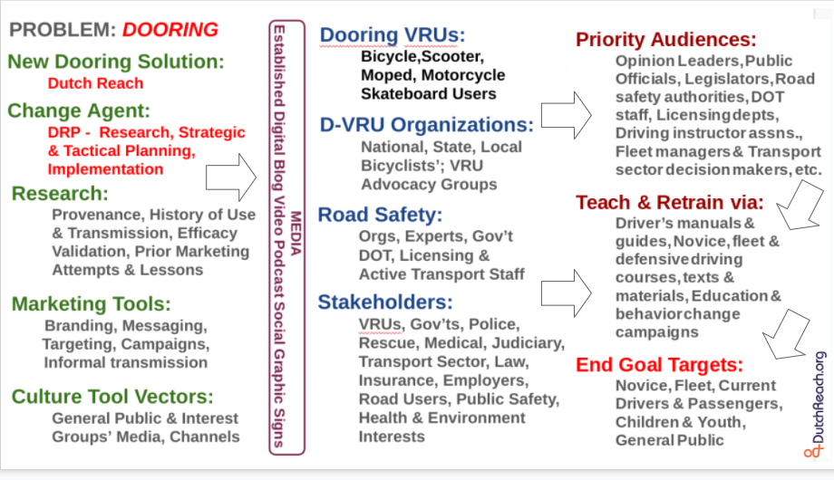
Dutch Reach Project Strategy Chart. DRP will introduce the Dutch anti dooring countermeasure into public road safety culture & established driver education & training programs.
Strategic plan proceeds from left to right. Left column: DRP develops research, resources & capacities to educate & influence important constituencies.
Outreach to constituencies [middle column] is made either directly or via electronic media transmission & amplification.
Persuaded allies & interest groups then promote the Dutch Reach directly to motorists, or lobby key decision makers & institutions to endorse, promote & teach the far hand Dutch method using their established educational means [right column].
DRP will then gather relevant news, media reports & new resources (graphics, videos, campaign ideas & materials etc.) making these available on the project website & also rebroadcast by the Project using social media.. A virtuous cycle of awareness, capacity, advocacy & progress will be generated as the Dutch Reach meme & Project spread to additional geographic & linguistic populations with anti-dooring need.

