Project input info preview – estimation of number of projects
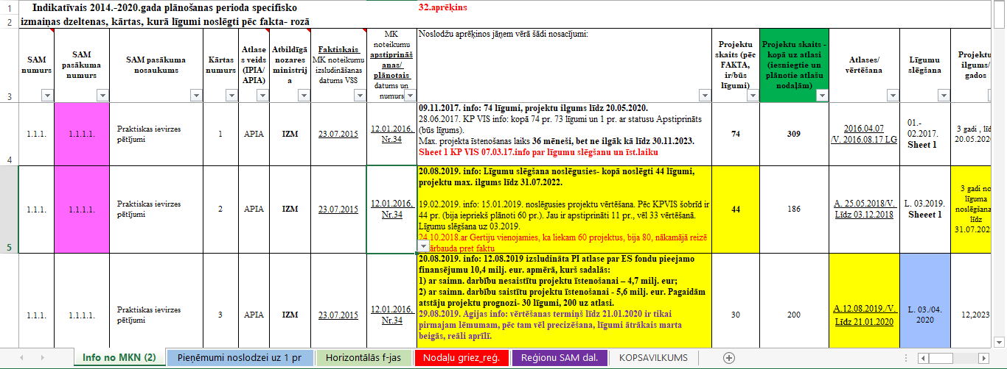

Calculation for support functions
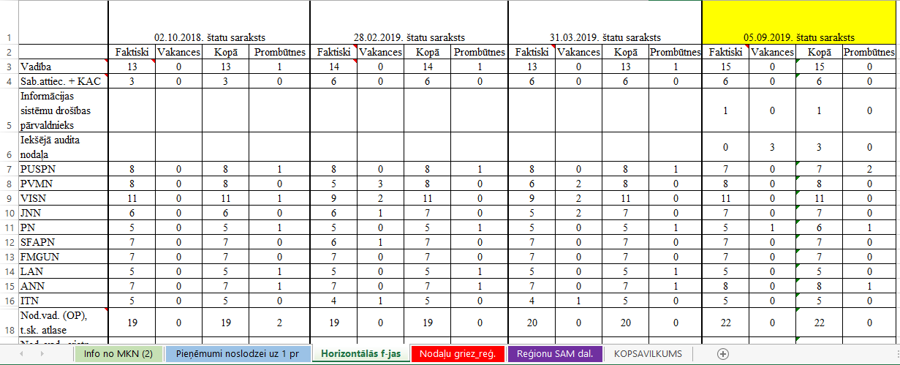

Workloud calculation preview for specific project groups (assumptions for 1 project yearly).
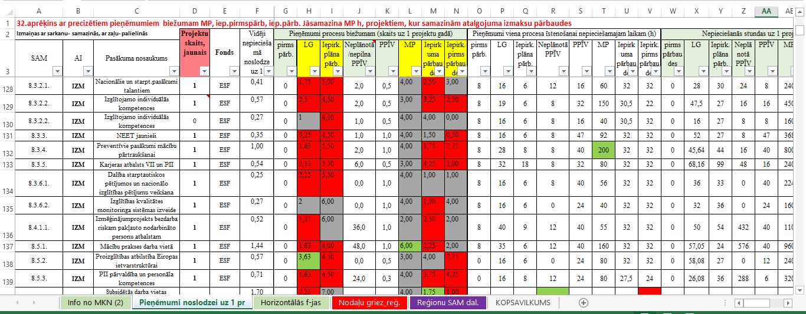

Summary of calculation and future workloud estimation
