Materials

Those two pictures can be added to the paragraph ´Anything Else´:
The most requested geospatial datasets on the Platform are:
- orthophoto maps for the whole territory of Latvia with a resolution of 0.25 meters prepared from aerial photography data. Data is available in raster data format GeoTIFF.
Link: www.lgia.gov.lv/en/ortofoto
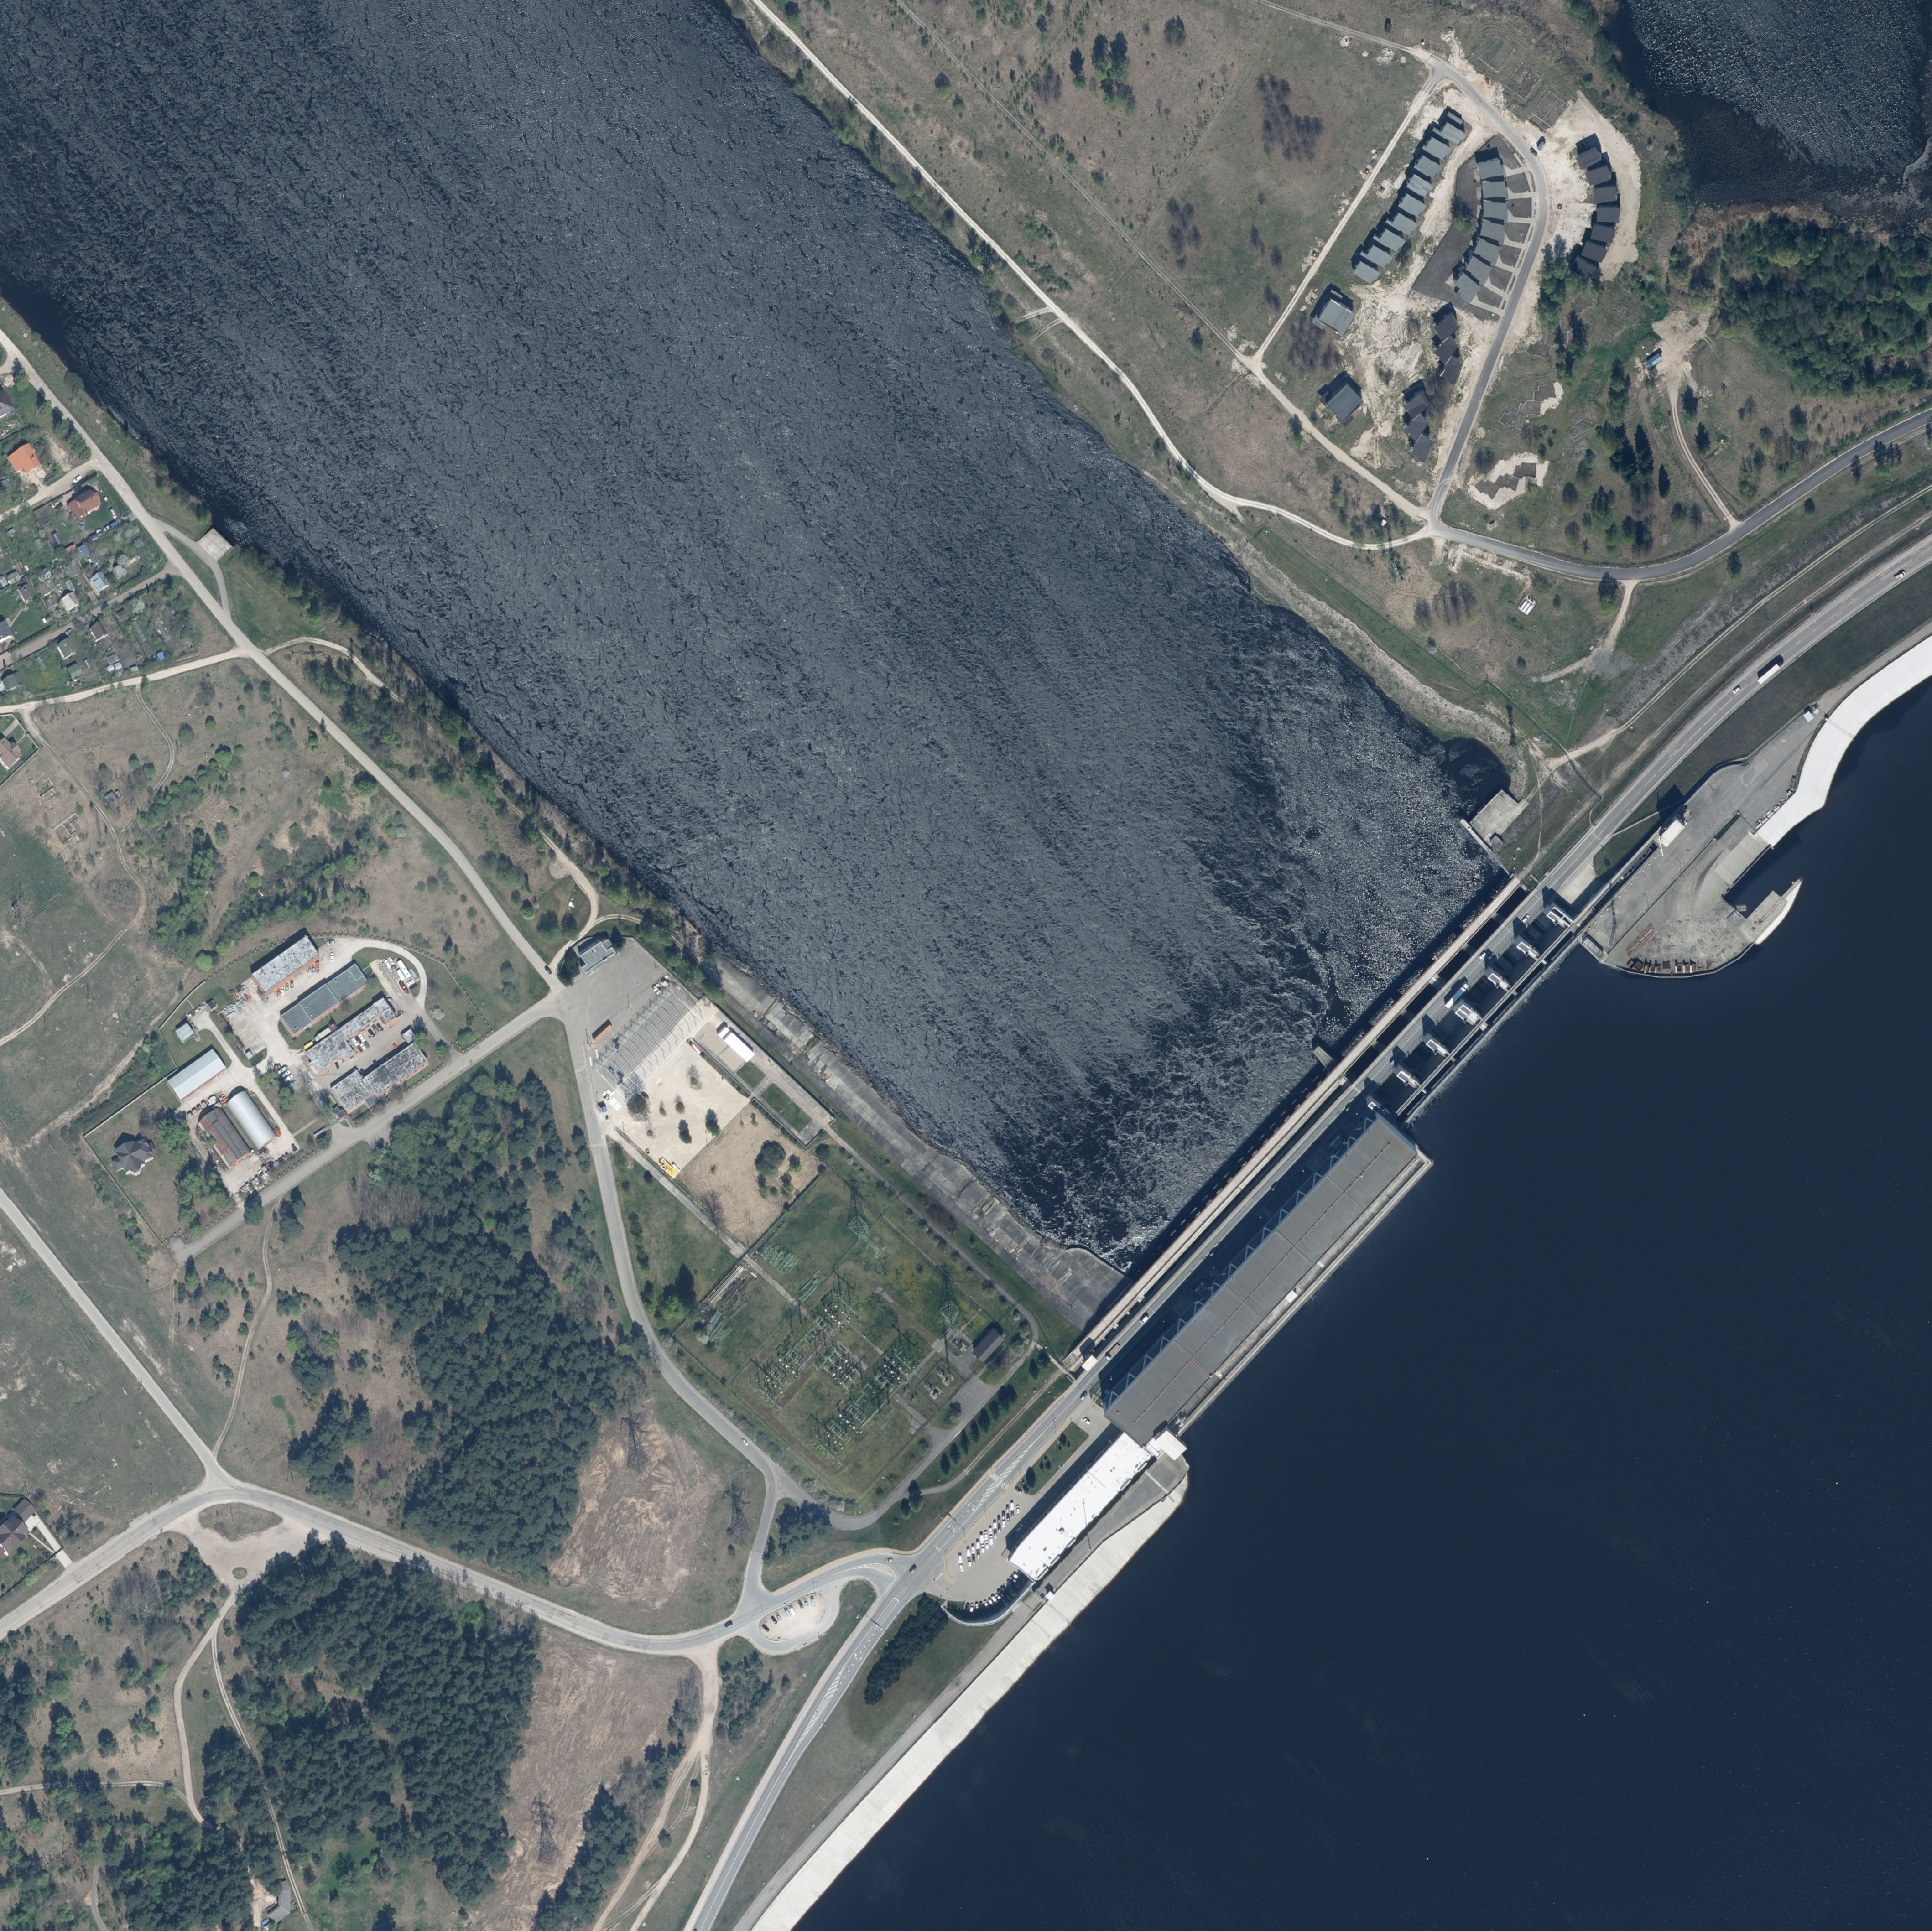
Orthophoto maps

- Digital Elevation Model Basic Data with a total point density of not less than 4 p/m² and an average point density of not less than 1.5p /m² based on aerial laser scanning data. Data is available in LAS format.
Link: www.lgia.gov.lv/en/Digit%C4%81lais%20surface%20model
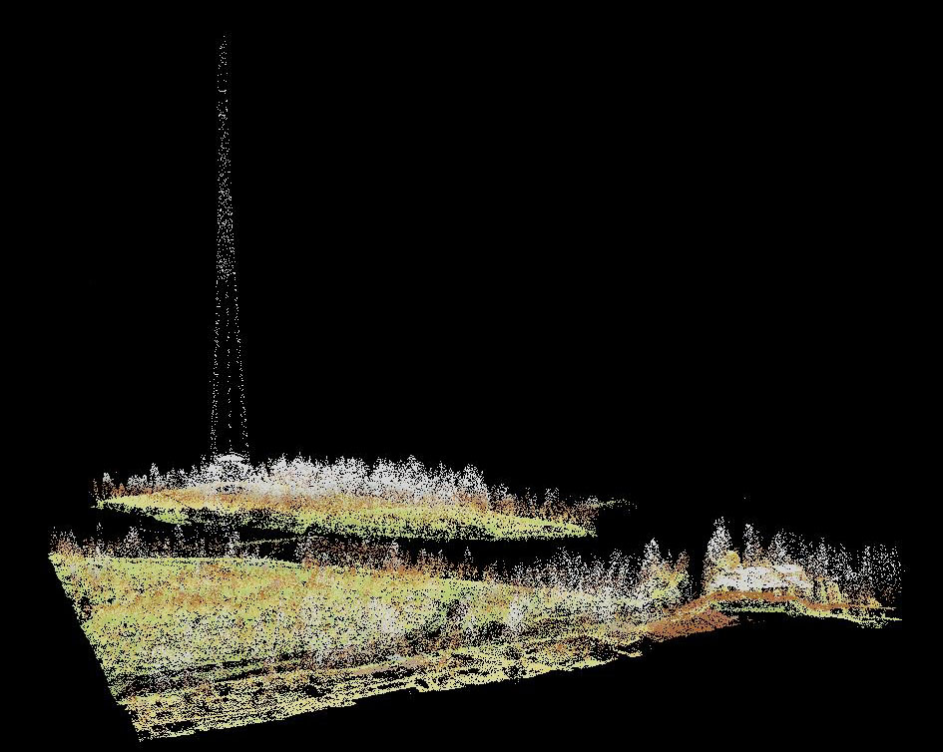
Digital Elevation Model

