Sijung Shinmun May 2, 2019
Page 11 (Capital Area)

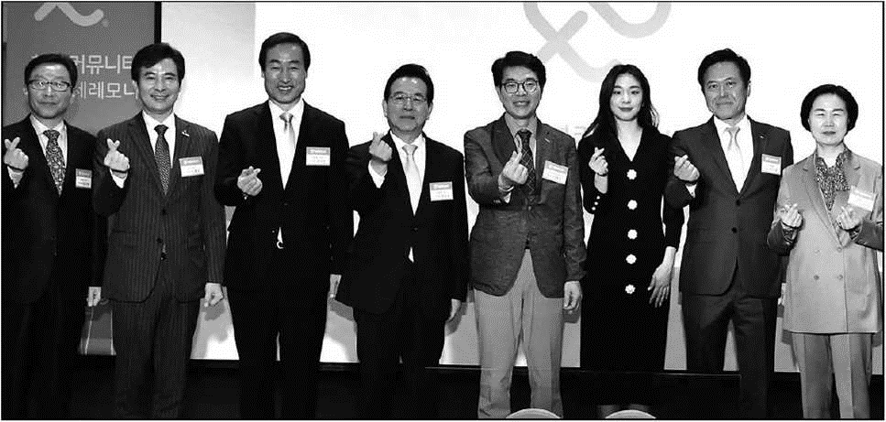
Seodaemun-gu to Provide AI Speakers to Socially Vulnerable Households
Governor of Seodaemun-gu Mun Seok-jin (third from left) is posing for a picture with other attendees of a ceremony held in SKT Tower in Jung-gu, Seoul, before the implementation of the ICT Care service. The attendees also included Governor of Gangnam-gu Jeong Sun-gyun, Governor of Seongdong-gu Jeong Won-o and Governor of Yangcheon-gu Kim Su-yeong.

Planning to Spread the AI Speaker Nugu to 200 Households by the End of the Year in Cooperation with SK Telecom

Seodaemun-gu (District Governor Moon Seok-jin) will provide AI speakers at no cost to vulnerable single-person households.
In order to reduce a feeling of loneliness in residents living alone including senior citizens, and to cope with emergencies, Seodaemun-gu has decided to distribute AI speaker "Nugu" to 200 households by the end of this year.
The AI ​​speaker Nugu can talk with users and provide music, weather information and latest news to them.
In addition, it can be linked to the smart switch and the door opening sensor, enabling users to control lighting and doors with their voice.
Seodaemun-gu also plans to use the data collected through Nugu to design and improve welfare services. In addition, if any abnormality, such as no conversation for a certain period, the District Office's personnel will respond to it in real-time including emergency visits.
SK Telecom will add the functions such as "Happy News" to provide guidance on how and when to intake medicine, "Happy Games" to prevent and diagnose dementia, and "Health Talk Talk" to offer health-related contents to the speaker.
Governor of Seodaemun-gu Mun Seok-jin attended a ceremony recently held at SKT Tower in Jung-gu, Seoul, ahead of the implementation of this ICT Care service.
The ceremony was also attended by Park Jung-ho, president of SK Telecom, officials from the Ministry of Science and ICT, and the heads of seven other municipalities including Seongdong-gu that participated in the project.
Meanwhile. Seodaemun-gu has provided the Smart Condition Check service that helps check the status of residents living alone based their mobile phone logs, which is the nation's first service of its kind, in cooperation with SK Telecom. Currently, about 16,000 residents are using the service. If the system fails to collect their mobile phone use records for a certain period of time, alerts are automatically sent to local community centers' welfare personnel so that they can contact the users via telephone or visit them, if necessary, to check their situation.
The service was benchmarked and introduced by Busan Metropolitan City, and Gangdong-gu, Seoul and other 10 municipalities including Seocho-gu and Dongdaemun-gu in Seoul, Seo-gu in Gwangju, Buk-gu in Ulsan, and Suncheon City are considering introduction of the service.
If local governments actively use advanced technologies as in the cases the Smart Condition Check and AI speaker care services, they will be able to more efficiently cope with residents' emergency situations and increase their satisfaction level with welfare services," said Governor of Seodaemun-gu Mun Seok-jin.
By Mun Myong-hye
myong5114@daum.net

